***BANK MANAGEMENT SYSTEM***

**DEPARTMENT OF INFORMATION TECHNOLOGY**

**K.E.S. ANANDIBAI PRADHAN SCIENCE COLLEGE , NAGOTHANE**

**(*Affiliated to University of Mumbai*)**

**NAGOTHANE**

**MAHARASHTRA**

**2021-22**



**BANK MANAGEMENT SYSTEM**

**A Project Report**

Submitted in partial fulfilment of the

Requirements for the award of the Degree of

**BACHELOR OF SCIENCE (INFORMATION TECHNOLOGY)**

**By**

Manali Raju Bhosale

825

**Under the esteemed guidance of**

**Miss Sonal Patil**

**Professor**

**KOKAN EDUCATION SOCIETY’S ANANDIBAI PRADHAN**

**SCIENCE COLLEGE , NAGOTHANE**

**(*Affiliated to University of Mumbai*)**

**NAGOTHANE-MAHARASHTRA-402106**

**DEPARTMENT OF INFORMATION TECHNOLOGY**



**CERTIFICATE**

This is to certify that the project entitled, "**SMS Based Remote Server Monitoring**", is bonafied work of **SHIVANI SUDHIR JAMBEKAR** bearing Seat.No: **835** submitted in partial fulfillment of the requirements for the award of degree of BACHELOR OF SCIENCE in INFORMATION TECHNOLOGY from University of Mumbai.

**Internal Guide Coordinator**

**ACKNOWLEDGMENT**

It gives me great pleasure to present my project on

**BANK MANAGEMENT SYSTEM**

I would like to express my special thanks of gratitude to my teacher **Miss. Sonal Patil** as well as our principle **Dr. Sandesh Gurav** who gave me the golden opportunity to do this wonderful project on the topic Bank Management System, which also helped me in doing a lot of research and I came to know about so many new things I am really thankful to them.

Secondly I would also like to thanks friends who helped me a lot in finishing this project within the limited time.

I am making this project not only for marks but to also increase my knowledge.

**THANKS AGAIN TO ALL WHO HELPED ME !!!**

**Miss. Manali Raju Bhosale**

**(TY.Bsc.IT)**

**ABSTRACT**

As the name specifies “BANK MANAGEMENT SYSTEM” is software developed for managing various activities in the bank. The Bank Management System undertaken as a project is based on relevant technologies. The main aim of this project is to developed software for bank management system. This project has been developed to carry out the process easily and quickly, which is not possible with the manual system, which are overcome by this software.

Requirements definition and management is recognized as a necessary step in a delivery of successful system and software project, discipline is also required by standards, regulation and quality improvement initiative. Creating and managing requirement is challenge of IT, system and product development project or indeed for any activities where you have to manage a contractual relationship. Organization need to effectively define and manage requirements to ensure they are meeting need of customer, while proving companies and stay on the schedule and with budge.

**DECLARATION**

I hereby declare that the project entitled, **“bank management** **System”** done at **K.E.S.** **Anandibai Pradhan Science College Nagothane**, has not been in any case duplicate to submit to any other university for the award of any degree. To the best of my Knowledge other than me, no one has submitted to any other university. The project is done partial fulfillment of the requirements for the award of degree of **BACHELOR OF SCIENCE (INFORMATION TECHNOLOGY)** to be submitted as final semester project as part of our curriculum.

**Miss. Manali Raju Bhosale**

**TABLE OF CONTENT**

|  |  |
| --- | --- |
| **SR.NO** | **TITLE** |
| **1.** | **Chapter1: Introduction** |
| **1.1** | Background |
| **1.2** | Objectives |
| **1.3** | Purpose, Scope and Applicability |
| **1.3.1** | Purpose |
| **1.3.2** | Scope |
| **1.3.3** | Applicability |
| **2.** | **Chapter2:Survey of Technologies** |
| **3.** | **Chapter3: System Analysis** |
| **3.1.** | Existing System |
| **3.2** | Proposed System |
| **3.3** | Requirement Analysis |
| **3.3.1** | Problem Definition |
| **3.3.2** | Planning Specification |
| **3.4** | Hardware Interface & Software Interface |
| **3.5** | Justification of Technologies |
| **3.6** | Preliminary Investigations |
| **4.** | **Chapter4: System Design** |
| **4.1** | Basic Modules |
| **4.1.1.** | Data Design |
| **4.1.2** | Data Integrity and Constraints |
| **4.2** | Procedural Design |
| **4.2.1** | Logic Diagram |
| **4.2.2** | Data Structure |
| **4.2.3** | Algorithm Design |
| **4.3** | User Interface |
| **4.4** | Security Issue |

**Chapter: 1**

**INTRODUCTION**

**INTRODUCTION**

A bank is a financial institution which accepts deposits, pays interest on pre-defined rates, clears checks, makes loans, and often acts as an intermediary in financial transactions. It also provides other financial services to its customers.

Bank management governs various concerns associated with bank in order to maximize profits. The concerns broadly include liquidity management, asset management, liability management and capital management. We will discuss these areas in later chapters. Bank Management System is based on a concept of recording customer’s account details. Here the user can perform all the tasks like creating an account, deposit amount, withdraw amount, check balance, view all account holders detail, close an account and modify an account. There’s no login system for this project. All the main features for banking system are set in this project.

**BACKGROUND**

The Project will make the workload easier for the workers and customer of the bank. This is because the application is connected to the signal database, so there is no need to transfer or make multiple back-ups of data. We will make is possible by using the prominent database techniques and object-oriented concept.

**OBJECTIVE**

The main objective of bank management system is to maximize the profit of the bank maintaining proper management of liquidity, asset, liability and capacity of the adequacy. For achieving this, bank must strictly follow some standards and organized system. To improve corporate social responsibility.

This document gives detailed functional and nonfunctional requirements system. This purpose of this document is that the requirements mentioned in it should be utilized by software developer to implement the system.

* To allow only authorized user to access various function and processed available in the system.
* Reduced clerical work as most of the work done by computer.
* Provide greater speed and reduced time consumption.

**PURPOSE**

This bank management system also allow user to add new customer account, delete account and user can also modify existing user account information. Online banking system provides is specifically developed for internet banking for balance Enquiry, Funds Transfer to another account in the same bank, Request for cheque book/change of address/stop payment of cheques, Mini statements (Viewing Monthly and annual statements).

The Traditional way of maintaining details of a user’s in a bank was to entry the details and records them. Every time the users need to entry time the user need to perform some transactions he has to go to bank and perform the necessary action, which may not be so feasible all the time. It may be a hard-hitting task for the users and the bankers too. The project gives real life understanding of Internet banking and activities performed by various roles in the supply chain. Here, we provide automation for banking system through Internet. Internet banking system project captures activities performed by different roles in real life banking which provides enhanced techniques for maintaining the required information up-to-date, which results in efficiency. The project gives real life understanding of Internet banking and activities performed by various roles in the supply chain.

**SCOPE OF THE PROJECT**

The main aim of an application is to somewhere automate records on the system. It gives all sorts of functions which are required by the bank in order to run a stable system. In addition to that it also helps to manually check the records of the pre-existing system like transactions that are made in the past. The application also changes or manipulates the new data that is being added and is then re-recorded. One can also check their present transactions that are in process and keep a check on their accounts via this application. It’s not only useful for the customers but also for the admin. Banking system is a way to maintain few records which bank holds in order to keep a track of everything in the bank so a software application is required in order to make the work easier, for example- maintenance of international value of INR and other currency are also a part of the job of banking system. The bank management is also required to act as the currency distributor and to serve the work for the nation’s well-being. This application is built to make it easier for the customers to track every transaction that is being made.

This product will automate of banking transaction process. This project investigates the entry threshold for providing a new transaction service channel via the real options approach, where the entry threshold is established by using an Internet banking system designed for the use of normal users(individuals), Industrialists, Entrepreneurs, Educational Institutions(Financial sections), Organizations and Academicians under transaction rate uncertainty.

Banking activities are considered to be the life blood of the national Economy. Without banking services, trading and business activities cannot be carried on smoothly. Banks are the distributers and protectors of liquid capital which is of vital significances to a developing country. Efficient administration of the banking system helps in the economic Growth of the nation. Banking is useful to trade and commerce.

* The failure of a lager institution could have serious ramifications for the entire system in that if one universal bank were to collapse, it could lead to a systemic financial crisis.
* Universal bankers may be tempted to take excessive risks.
* Banks may deploy their own assets in securities with consequent risk to commercial and savings deposits.
* Vulnerable to high risks due to investment banking activities coupled with focus on commercial banking activities.
* Unsound loans may be made in order to shore up the price of securities or the financial position of companies in which a bank had invested its own assets.

**APPLICABILITY**

The Bank Management System is an application for maintaining a person’s account in a bank. To developed the project for solving finance application of a customer in bank environment in order to nature the need of an end banking users by providing various ways to perform banking task.

**Chapter: 2**

**SURVEY OF TECHNOLOGY**

**SURVEY OF TECHNOLOGY**

Microsoft Visual Studio is an integrated development environment (IDE) from Microsoft. It is used to develop computer programs, as well as websites, web apps, web services and mobile apps. Visual Studio uses Microsoft software development platforms such as Windows API, Windows Forms, Windows Presentation Foundation, Windows Store and Microsoft Silverlight. It can produce both native code and managed code.

Visual Studio supports 36 different programming languages and allows the code editor and debugger to support (to varying degrees) nearly any programming language, provided a language-specific service exists. Built-in languages include php, HTML, C, C++, C++/CLI, Visual Basic .NET, C#, F#, JavaScript, TypeScript, XML, XSLT, andCSS.

**Microsoft Visual** php**,** HTML,Microsoft's implementation of the php language, along with the language services that lets the Visual Studio XAMPP support php projects. While the language services are a part of Visual Studio, the compiler is available separately as a part of the xampp. The Visual in php 2008, 2010 and 2012 compilers support versions 3.0, 4.0 and 5.0 of the C# language specifications, respectively. Visual C# supports the Visual Studio Class designer, Forms designer,and Data designer, and Data designer among others**.**

credit unions had already deployed these tools—heading into 2021, that percentage is roughly 30%.

1. Person-To-Person (P2P) Payments

P2P payments are certainly growing in popularity among consumers, but the P2P payment replacement cycle in financial institutions is starting to wind down.

For 2021, about a quarter of banks and a fifth of credit unions expect to select a new or replacement P2P tool. That’s down from the roughly 30% who expected to deploy one in 2020, which, in turn, was down from the 35% who planned to do so in 2019.

1. Cloud Computing

The percentage of banks that have deployed cloud computing increased significantly in 2020, going from 32% at the end of 2019 to 40% at the end of 2020. Half of credit unions are already there.

The challenge for the tech vendors has morphed, however, from evangelizing the cloud (with claims of faster speed-to-market and lower total cost of ownership) to presenting tangible migration strategies and realistic projections of process and cost impacts.

**PROBLEM DEFINATION**

Although the basic type of services offered by a bank depends upon the type of bank and the country, services provided usually including: Taking deposits from their customers and issuing currents or checking accounts and saving accounts to individuals and business. Extending loans to individuals and business, cashing cheque. Facilitating money transaction such as wire transfer and cashiers cheque, consumer and commercial financial advisory services, financial transaction can be performed through many different channels.

**REQUIRE SPECIFICATION-**

Clear requirements help development teams create the right product. And software requirements specifications (SRS) help you lay the groundwork for products development. We’ll define what this is, when you’d use one, and five step to writing an SRS Document.

This section provides the functional overview of the product. The project will require the PHP as a front end and at the back end the database MYSQL will be running. Various functionality modules that can be implemented by the product will be:

1. Login
2. Validation
3. Get balance information
4. Withdrawal of money
5. Transfer Money
6. Customer information

**Planning And Scheduling**

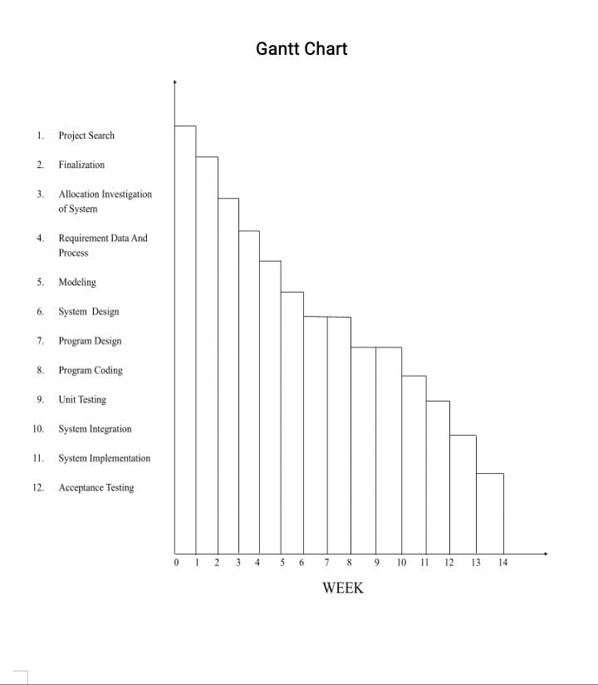

**PLANING AND SPECIFICATIONS**

In order to develop our schedule, we first need to define the activities, sequence them in the right order, estimate the resources needed, and estimate the time it will take to complete the tasks.

The activity definition process is a further breakdown of the work package elements of the WBS. It docu­ments the specific activities needed to fulfill the deliverables detailed in the WBS. These activities are not the deliverables themselves but the individual units of work that must be completed to fulfill the deliverables. Activity definition uses everything we already know about the project to divide the work into activities that can be estimated. You might want to look at all the lessons learned from similar projects your company has done to get a good idea of what you need to do on the current one.

Expert judgment in the form of project team members with prior experience developing project scope statements and WBS can help you define activities. If you are asked to manage a project in a new domain, you might also use experts in that particular field to help define tasks so you can understand what activities are going to be involved. You may want to create an activity list and then have the expert review it and suggest changes. Alternatively, you could involve the expert from the very beginning and ask to have an activity definition conversation with him or her before even making your first draft of the list.

Sometimes you start a project without knowing a lot about the work that you’ll be doing later. Rolling-wave planning lets you plan and schedule only the portion that you know enough about to plan well. When you don’t know enough about a project, you can use placeholders for the unknown portions until you know more. These are extra items that are put at high levels in the WBS to allow you to plan for the unknown.

**Hardware Interface and Software Interface**

* Hardware Interface

Various interfaces for the product could be

1. Touch screen/Monitor
2. Keypad
3. Continuous battery backup
4. Printer which can produced the hard copy.
5. Interface that connects the device to bank’s computer.
6. An interface that can count currency notes.

* Software Interface

1. Any windows operating system.
2. The PHP must be installed. For the database handling MYSQL must be installed. These products are open source products.
3. The final application must be packaged in a set up program, so that the product can be easily installed on machines. This application must be networked to corresponding banks.

**Preliminary Investigation**

For this, the need arises to understand the viewpoint of two important entities …

* How to present system work?
* What are drawbacks are in the present system?
* What is their vision about the new system?
* What specific facilities they want from new system, those are currently not in scope of existing system?
* How will be authenticated to access data and his/her access rights?

To find more about present system’s working mechanism such as the ways of getting inputs and providing outputs, I interviewed the current users of the system by asking following questions:

* Are they comfortable with the person system?
* What flaws exist in the current system?
* Do they feel the necessity of new system?
* What will be their requirements from new system?
* Are they satisfied with their role in new system?

After carrying out these interviews, I drew conclusion about the top management’s requirement and whether users are in support of the new system.

**Justification of the project**

On a successful completion and implementation of this project,

users/customers will be rest assured that no amount of online

threat from hacker and other attackers can penetrate their

account even when their password is compromised.

This application uses a multi-level security measure to ensure

that customers’ personal details and account information are

safe.

**proposed system:**

More secure information will give a layer of security of authentication and authorization.

Required very little manpower.

Simplify the problem of editing.

Maintain the clearance level by the hierarchy.

The information will be secure from the different types of disasters as there will be an automatic backup system for the customer and bank information.

Maintain data integrity Validate the manual calculations avoid calculation error.

Safeguard the data accuracy.

More reliable and efficient.

More user-friendly interface.

**User Interface**

**ERDIAGRAM:-(Entity Relationship Diagram):**

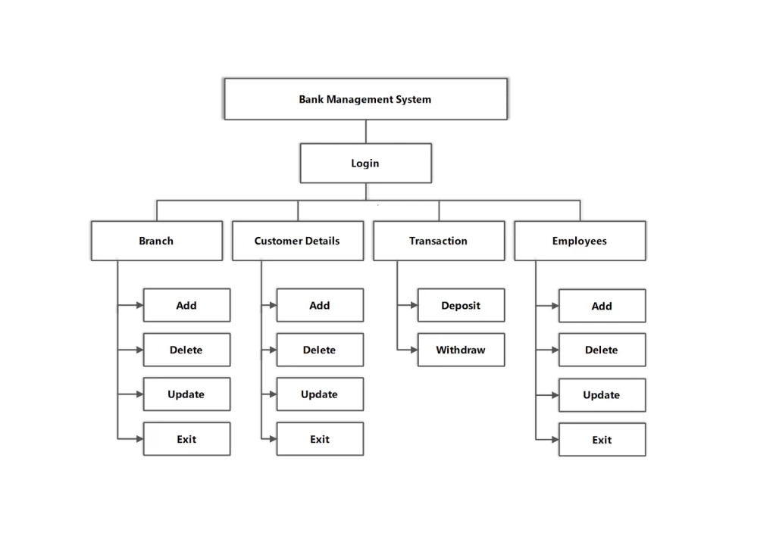

**DATA FLOW DIAGRAM:-**

Customer Management

Customer Management

Current Account Management

Employee Management

Saving Account Management

Fixed Deposit Management

**Chapter: 4**

**SYSTEM DESIGN**

**BASIC MODULES**

1. **Customer :** These are the main source of business for the bank. The number of the customer will improve the position in the market.
2. **Customer-id:** This is the primary key the particular table. It will be used to find the customers personal details.
3. **Customer-name:** The customer will be for the document verification for the account opening.
4. **Customer-address**: To send any envelope to the customer’s residence or any contact to the address.
5. **Customer-phone:** To communicate with the customers over the phone.
6. **Customer-email:** To send any offer from the bank to the customer or formal communication with the customer.
7. **Account-number:** This will link the account to the user’s banking details like the transaction or the balance of this account holder.

**Schema Design:-**

**Tables:-**

Customer:-

|  |  |  |
| --- | --- | --- |
| Customer Name | Data type | Constraints |
| C_ID | Numeric | Primary key |
| C_Name | Varchar | Not Null |
| Customer Name | Varchar | Not Null |
| Account Number | Numeric | Not Null |
| Password | Nvar | Not Null |
| Email | Nvar | Not Null |
| DOB | Numeric | Not Null |
| Mobile No | Numeric | Not Null |
| Address | Varchar | Not Null |
| City | Varchar | Not Null |
| State | Varchar | Not Null |
| Country | Varchar | Not Null |

Employee Table:-

|  |  |  |
| --- | --- | --- |
| Field Name | Data type | Constraints |
| Emp_ID | Numeric | Primary Key |
| Emp_Name | Varchar | Not Null |
| Address | Varchar | Not Null |
| Contact No | Numeric | Not Null |
| Work | Varchar | Not Null |
| Qualification | Numeric | Not Null |
| Salary | Numeric | Not Null |

New Account Table:-

|  |  |  |
| --- | --- | --- |
| Address | Data type | Constraints |
| C_Name | Varchar | Primary Key |
| Account Type | Numeric | Not Null |
| Current Date Time | Numeric | Not Null |

S

**Procedural Design**

**Control Flow Chart:-**

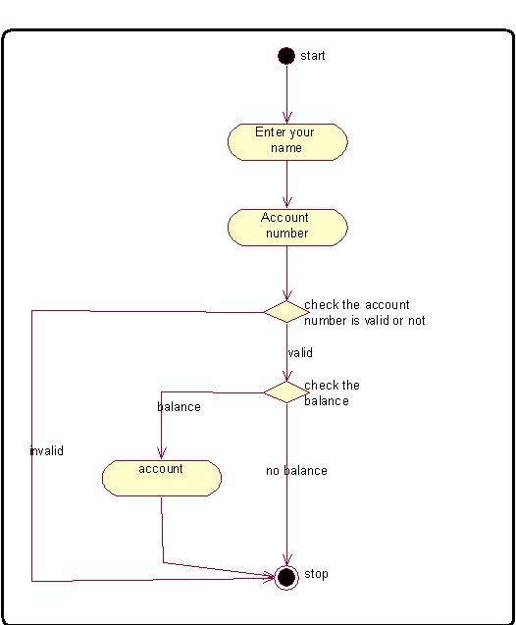

**Data Structure**

**CUSTOMER TABLE:-**

CREATE TABLE Customer _info(C_ID Preliminary Key , C_NAME Varcher Not Null, User Name Not Null, Account Number Not Null, Password NVar Not Null, Email Nvar Not Null, DOB int Not Null, Age int Not Null, Mobil int Not Null, Address varchar Not Null, City verchar Not Null, State varchar Not Null, country varchar Not Null )

**EMPLOYEE TABLE:-**

CREATE TABLE Employee_info (Emp_ID int (10) Preliminary key, Emp_Name Varchar (20) Not Null, Address Varchar (20) Not Null, Contact No. int (20) Not Null, Work Varchar (20) Not Null, Qualification int (20) Not Null, Salary int (20) Not Null)

**NEW ACCOUNT TABLE:-**

CREATE TABLE New Account_info (C_Name Varchar (20) Preliminary key, Account Type int (20) Not Null, Current date int (20) Not Null)

**Algorithm Design**

1. Algorithm for create Account:-

Step 1: Create a new Account

Step 2: Choose console application

Step 3: Name your project

Step 4: The actual code

Step 5: Function for date

Step 6: Function for customer attribute

Step 7: The adding new account

Step 8: View list of record

Step 9: Update record of customer

Step 10: The transaction of customer

Step 11: The delete record of customer

Step 12: The viewing of interest

Step 13: The function for the password

**SEQUENCE DIAGRAM**

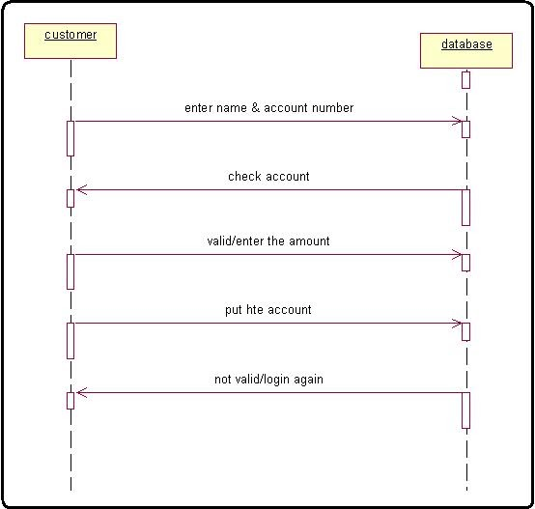

**SECURITY ISSUE**

## Bank Security

In the current banking landscape, security is a major problem that the industry faces. One of the risks is cyber security. These security breaches then lead to frauds and other such malpractices. The number of cases of bank frauds are rising every year. Let us take a look at some of the major bank security issues we are currently facing.

### Mobile Banking Risks

During the last five years or so, mobile banking has gained relevance in a India. The volume of funds transferred through mobile banking has jumped 108% since last year. However, mobile banking has many security issues. For once the safeguards put in place for online banking do not translate well on the mobile apps.

Also, viruses in smartphones are quite common, and they can override the security settings in the app. And finally, the app needs constant updates so the bugs and viruses are taken care of. If the user does not update his app he can be vulnerable.

**Index Pages:**

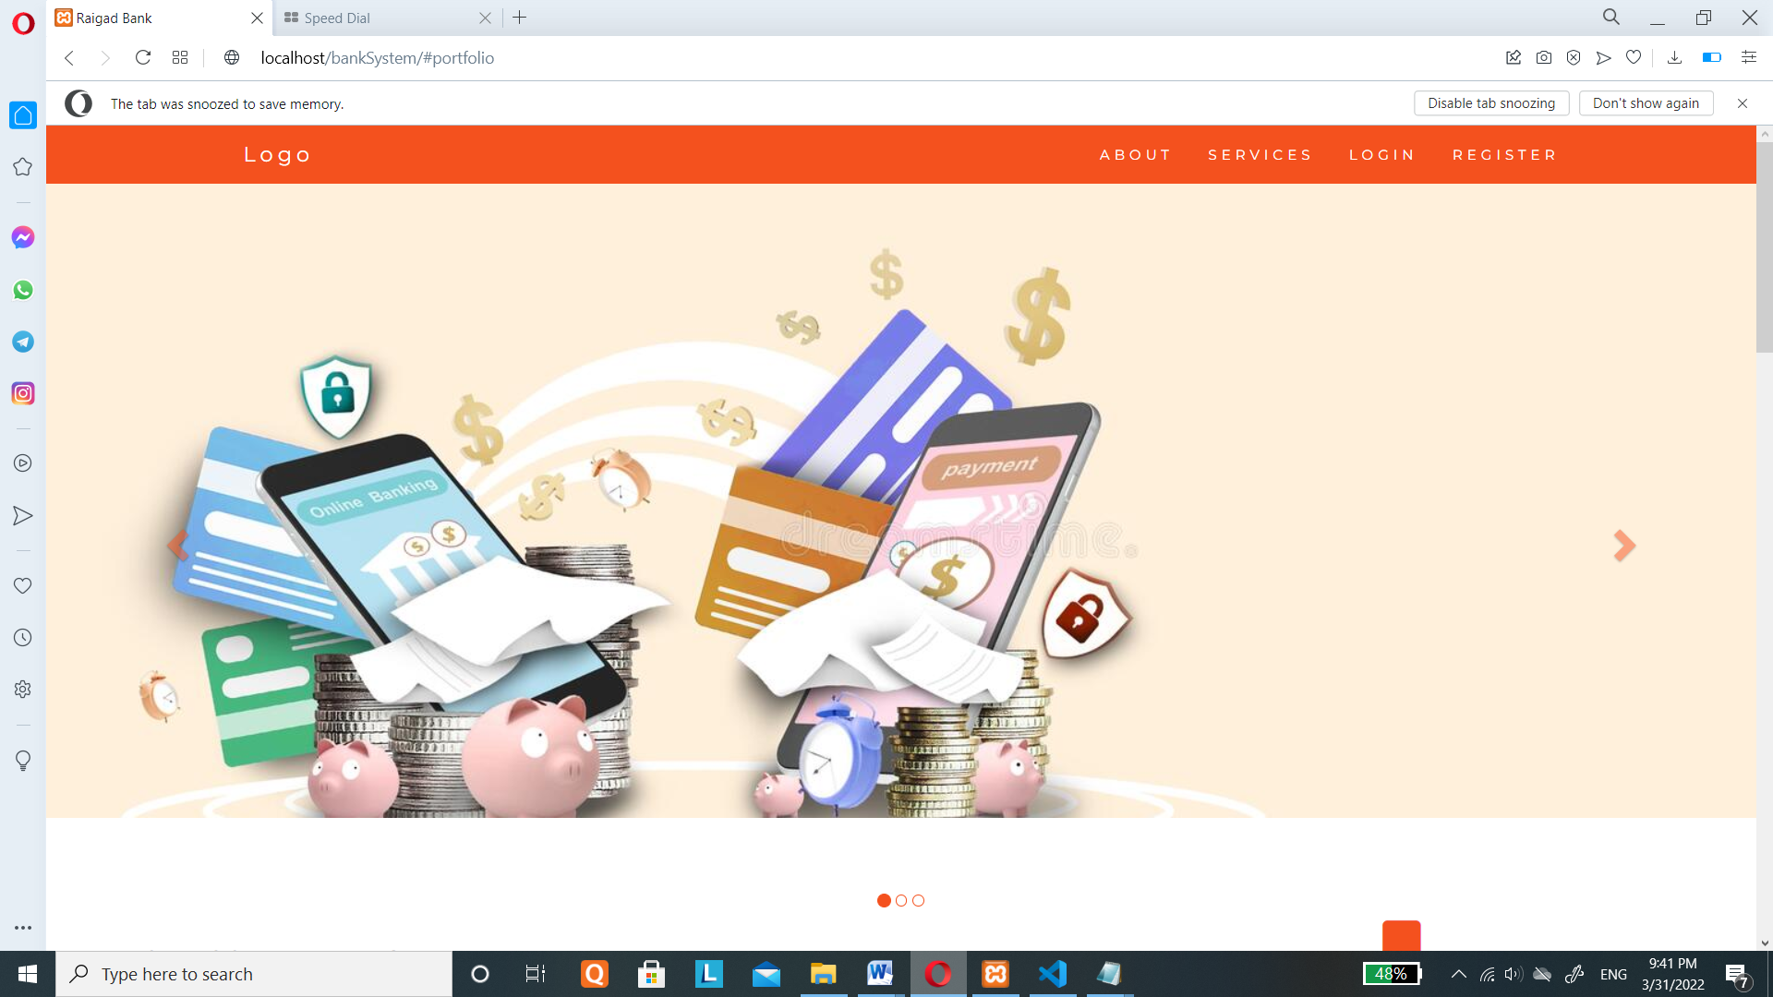

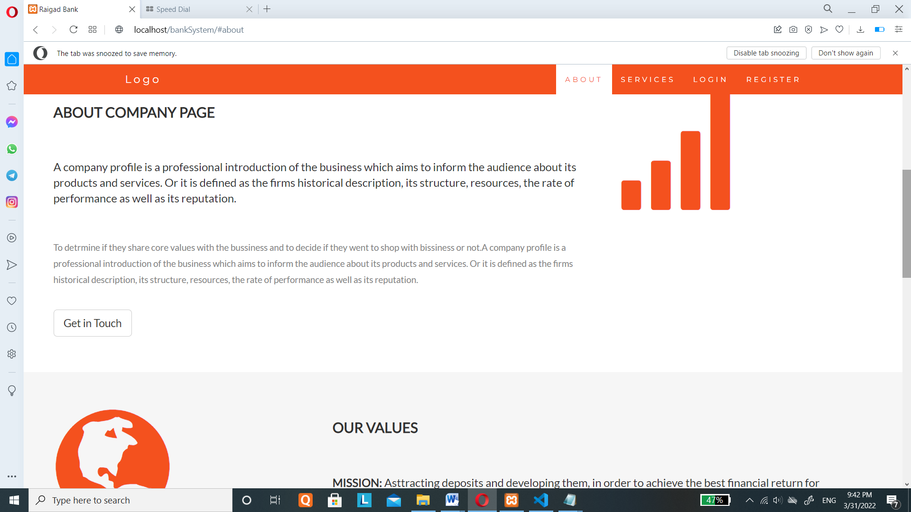

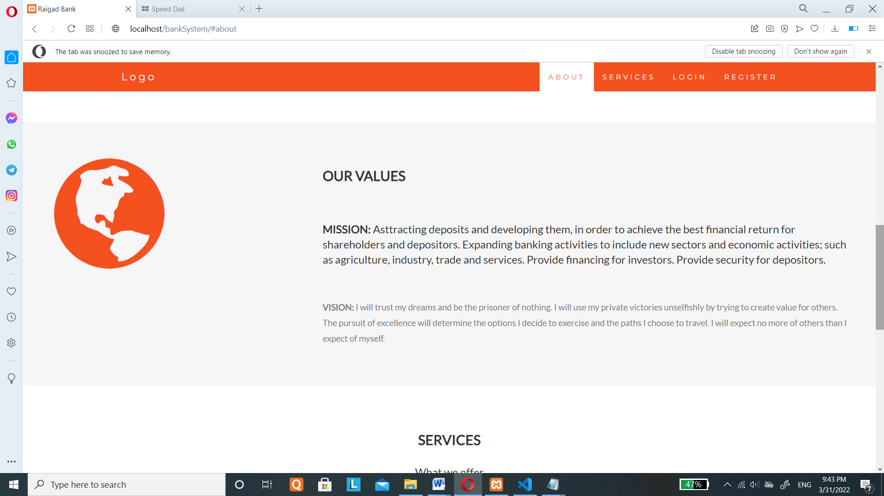

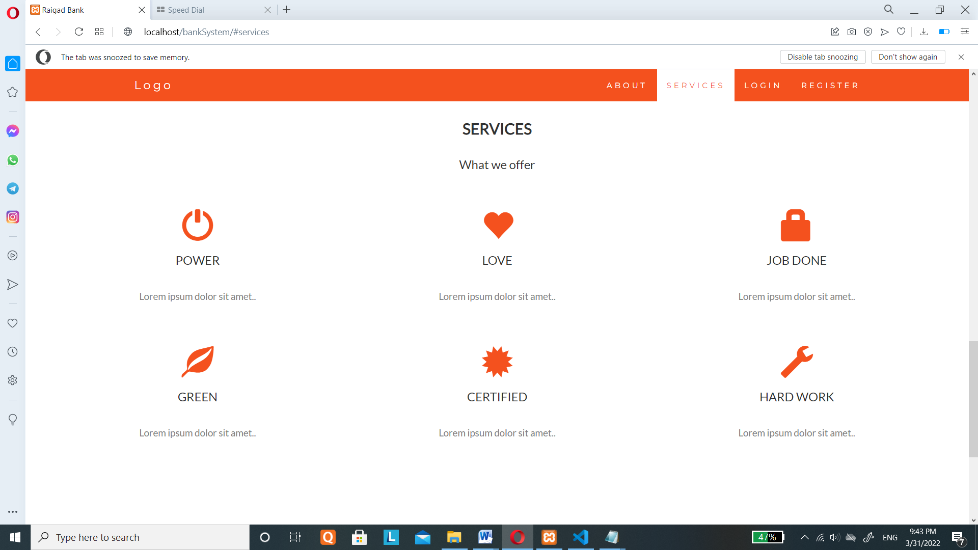

<!DOCTYPE html>

<html lang="en">

<head>

  <!-- Theme Made By www.w3schools.com

  https://www.w3schools.com/bootstrap/trybs_theme_company_full.htm

  -->

  <title>Raigad Bank</title>

  <meta charset="utf-8">

  <meta name="viewport" content="width=device-width, initial-scale=1">

  <link rel="stylesheet" href="https://maxcdn.bootstrapcdn.com/bootstrap/3.4.1/css/bootstrap.min.css">

  <link href="https://fonts.googleapis.com/css?family=Montserrat" rel="stylesheet" type="text/css">

  <link href="https://fonts.googleapis.com/css?family=Lato" rel="stylesheet" type="text/css">

  <script src="https://ajax.googleapis.com/ajax/libs/jquery/3.5.1/jquery.min.js"></script>

  <script src="https://maxcdn.bootstrapcdn.com/bootstrap/3.4.1/js/bootstrap.min.js"></script>

  <style>

  body {

      font: 400 15px Lato, sans-serif;

      line-height: 1.8;

      color: #818181;

  }

  h2 {

      font-size: 24px;

      text-transform: uppercase;

      color: #303030;

      font-weight: 600;

      margin-bottom: 30px;

  }

  h4 {

      font-size: 19px;

      line-height: 1.375em;

      color: #303030;

      font-weight: 400;

      margin-bottom: 30px;

  }

  .jumbotron {

      /*background-color: #f4511e;*/

      height: 600px;

      background-image: url('images/banner_img.jpg');

      color: #fff;

      padding: 100px 25px;

      font-family: Montserrat, sans-serif;

  }

  .container-fluid {

      padding: 60px 50px;

  }

  .bg-grey {

      background-color: #f6f6f6;

  }

  .logo-small {

      color: #f4511e;

      font-size: 50px;

  }

  .logo {

      color: #f4511e;

      font-size: 200px;

  }

  .thumbnail {

      padding: 0 0 15px 0;

      border: none;

      border-radius: 0;

  }

  .thumbnail img {

      width: 100%;

      height: 100%;

      margin-bottom: 10px;

  }

  .carousel-control.right, .carousel-control.left {

      background-image: none;

      color: #f4511e;

  }

  .carousel-indicators li {

      border-color: #f4511e;

  }

  .carousel-indicators li.active {

      background-color: #f4511e;

  }

  .item h4 {

      font-size: 19px;

      line-height: 1.375em;

      font-weight: 400;

      font-style: italic;

      margin: 70px 0;

  }

  .item span {

      font-style: normal;

  }

  .panel {

      border: 1px solid #f4511e;

      border-radius:0 !important;

      transition: box-shadow 0.5s;

  }

  .panel:hover {

      box-shadow: 5px 0px 40px rgba(0,0,0, .2);

  }

  .panel-footer .btn:hover {

      border: 1px solid #f4511e;

      background-color: #fff !important;

      color: #f4511e;

  }

  .panel-heading {

      color: #fff !important;

      background-color: #f4511e !important;

      padding: 25px;

      border-bottom: 1px solid transparent;

      border-top-left-radius: 0px;

      border-top-right-radius: 0px;

      border-bottom-left-radius: 0px;

      border-bottom-right-radius: 0px;

  }

  .panel-footer {

      background-color: white !important;

  }

  .panel-footer h3 {

      font-size: 32px;

  }

  .panel-footer h4 {

      color: #aaa;

      font-size: 14px;

  }

  .panel-footer .btn {

      margin: 15px 0;

      background-color: #f4511e;

      color: #fff;

  }

  .navbar {

      margin-bottom: 0;

      background-color: #f4511e;

      z-index: 9999;

      border: 0;

      font-size: 12px !important;

      line-height: 1.42857143 !important;

      letter-spacing: 4px;

      border-radius: 0;

      font-family: Montserrat, sans-serif;

  }

  .navbar li a, .navbar .navbar-brand {

      color: #fff !important;

  }

  .navbar-nav li a:hover, .navbar-nav li.active a {

      color: #f4511e !important;

      background-color: #fff !important;

  }

  .navbar-default .navbar-toggle {

      border-color: transparent;

      color: #fff !important;

  }

  footer .glyphicon {

      font-size: 20px;

      margin-bottom: 20px;

      color: #f4511e;

  }

  .slideanim {visibility:hidden;}

  .slide {

      animation-name: slide;

      -webkit-animation-name: slide;

      animation-duration: 1s;

      -webkit-animation-duration: 1s;

      visibility: visible;

  }

  @keyframes slide {

    0% {

      opacity: 0;

      transform: translateY(70%);

    }

    100% {

      opacity: 1;

      transform: translateY(0%);

    }

  }

  @-webkit-keyframes slide {

    0% {

      opacity: 0;

      -webkit-transform: translateY(70%);

    }

    100% {

      opacity: 1;

      -webkit-transform: translateY(0%);

    }

  }

  @media screen and (max-width: 768px) {

    .col-sm-4 {

      text-align: center;

      margin: 25px 0;

    }

    .btn-lg {

        width: 100%;

        margin-bottom: 35px;

    }

  }

  @media screen and (max-width: 480px) {

    .logo {

        font-size: 150px;

    }

  }

  </style>

</head>

<body id="myPage" data-spy="scroll" data-target=".navbar" data-offset="60">

<nav class="navbar navbar-default navbar-fixed-top">

  <div class="container">

    <div class="navbar-header">

      <button type="button" class="navbar-toggle" data-toggle="collapse" data-target="#myNavbar">

        <span class="icon-bar"></span>

        <span class="icon-bar"></span>

        <span class="icon-bar"></span>

      </button>

      <a class="navbar-brand" href="#myPage">Logo</a>

    </div>

    <div class="collapse navbar-collapse" id="myNavbar">

      <ul class="nav navbar-nav navbar-right">

        <li><a href="#about">ABOUT</a></li>

        <li><a href="#services">SERVICES</a></li>

        <!--<li><a href="#pricing">PRICING</a></li>

        <li><a href="#contact">CONTACT</a></li>-->

        <li><a href="#" data-toggle="modal" data-target="#myModal_login">LOGIN</a></li>

        <li><a href="#" data-toggle="modal" data-target="#myModal_reg">REGISTER</a></li>

      </ul>

    </div>

  </div>

</nav>

<div class="jumbotron text-center">

  <!--<h1>Company</h1>

  <p>We specialize in blablabla</p>

  <form class="form-inline">

    <div class="input-group">

      <input type="email" class="form-control" size="50" placeholder="Email Address" required>

      <div class="input-group-btn">

        <button type="button" class="btn btn-danger">Subscribe</button>

      </div>

    </div>

  </form>-->

</div>

<!-- Container (About Section) -->

<div id="about" class="container-fluid">

  <div class="row">

    <div class="col-sm-8">

      <h2>About Company Page</h2><br>

      <h4>A company profile is a professional introduction of the business which aims to inform the audience about its products and services. Or it is defined as the firms historical description, its structure, resources, the rate of performance as well as its reputation.</h4><br>

      <p>To detrmine if they share core values with the bussiness and to decide if they went to shop with bissiness or not.A company profile is a professional introduction of the business which aims to inform the audience about its products and services. Or it is defined as the firms historical description, its structure, resources, the rate of performance as well as its reputation.</p>

      <br><button class="btn btn-default btn-lg">Get in Touch</button>

    </div>

    <div class="col-sm-4">

      <span class="glyphicon glyphicon-signal logo"></span>

    </div>

  </div>

</div>

<div class="container-fluid bg-grey">

  <div class="row">

    <div class="col-sm-4">

      <span class="glyphicon glyphicon-globe logo slideanim"></span>

    </div>

    <div class="col-sm-8">

      <h2>Our Values</h2><br>

      <h4><strong>MISSION:</strong> Asttracting deposits and developing them, in order to achieve the best financial return for shareholders and depositors. Expanding banking activities to include new sectors and economic activities; such as agriculture, industry, trade and services. Provide financing for investors. Provide security for depositors.</h4><br>

      <p><strong>VISION:</strong> I will trust my dreams and be the prisoner of nothing.

       I will use my private victories unselfishly by trying to create value for others. The pursuit of excellence will determine the options I decide to exercise and the paths I choose to travel. I will expect no more of others than I expect of myself. </p>

    </div>

  </div>

</div>

<!-- Container (Services Section) -->

<div id="services" class="container-fluid text-center">

  <h2>SERVICES</h2>

  <h4>What we offer</h4>

  <br>

  <div class="row slideanim">

    <div class="col-sm-4">

      <span class="glyphicon glyphicon-off logo-small"></span>

      <h4>POWER</h4>

      <p>Lorem ipsum dolor sit amet..</p>

    </div>

    <div class="col-sm-4">

      <span class="glyphicon glyphicon-heart logo-small"></span>

      <h4>LOVE</h4>

      <p>Lorem ipsum dolor sit amet..</p>

    </div>

    <div class="col-sm-4">

      <span class="glyphicon glyphicon-lock logo-small"></span>

      <h4>JOB DONE</h4>

      <p>Lorem ipsum dolor sit amet..</p>

    </div>

  </div>

  <br><br>

  <div class="row slideanim">

    <div class="col-sm-4">

      <span class="glyphicon glyphicon-leaf logo-small"></span>

      <h4>GREEN</h4>

      <p>Lorem ipsum dolor sit amet..</p>

    </div>

    <div class="col-sm-4">

      <span class="glyphicon glyphicon-certificate logo-small"></span>

      <h4>CERTIFIED</h4>

      <p>Lorem ipsum dolor sit amet..</p>

    </div>

    <div class="col-sm-4">

      <span class="glyphicon glyphicon-wrench logo-small"></span>

      <h4 style="color:#303030;">HARD WORK</h4>

      <p>Lorem ipsum dolor sit amet..</p>

    </div>

  </div>

</div>

    <!-- Indicators -->

    <ol class="carousel-indicators">

      <li data-target="#myCarousel" data-slide-to="0" class="active"></li>

      <li data-target="#myCarousel" data-slide-to="1"></li>

      <li data-target="#myCarousel" data-slide-to="2"></li>

    </ol>

    <!-- Wrapper for slides -->

    <div class="carousel-inner" role="listbox">

      <div class="item active">

        <h4>"This company is the best. I am so happy with the result!"<br><span>Michael Roe, Vice President, Comment Box</span></h4>

      </div>

      <div class="item">

        <h4>"One word... WOW!!"<br><span>John Doe, Salesman, Rep Inc</span></h4>

      </div>

      <div class="item">

        <h4>"Could I... BE any more happy with this company?"<br><span>Chandler Bing, Actor, FriendsAlot</span></h4>

      </div>

    </div>

    <!-- Left and right controls -->

    <a class="left carousel-control" href="#myCarousel" role="button" data-slide="prev">

      <span class="glyphicon glyphicon-chevron-left" aria-hidden="true"></span>

      <span class="sr-only">Previous</span>

    </a>

    <a class="right carousel-control" href="#myCarousel" role="button" data-slide="next">

      <span class="glyphicon glyphicon-chevron-right" aria-hidden="true"></span>

      <span class="sr-only">Next</span>

    </a>

  </div>

</div>

  <!-- Modal -->

  <div class="modal fade" id="myModal_login" role="dialog">

    <div class="modal-dialog" style="margin: 130px auto;">

      <!-- Modal content-->

      <div class="modal-content">

        <div class="modal-header">

          <button type="button" class="close" data-dismiss="modal">&times;</button>

          <center><h4 class="modal-title">Login</h4>

          <p>Please fill in this form to login to your account.</p></center>

        </div>

        <div class="modal-body">

            <form action="action.php" method="post">

                <input type="hidden" value="yes" name="loginaction">

                <label for="uname"><b>Username</b></label>

                <input class="form-control" type="text" placeholder="Enter Username" name="uname" required>

                <label for="psw"><b>Password</b></label>

                <input class="form-control" type="password" placeholder="Enter Password" name="psw" required>

                <br>

                <button type="submit" class="form-control btn btn-success">Login</button>

            </form>

        </div>

        <div class="modal-footer">

          <button type="button" class="btn btn-default" data-dismiss="modal">Close</button>

        </div>

      </div>

    </div>

  </div>

  <!-- end Modal -->

  <!-- Modal -->

  <div class="modal fade" id="myModal_reg" role="dialog">

    <div class="modal-dialog modal-lg" style="margin: 110px auto;">

      <!-- Modal content-->

      <div class="modal-content">

        <div class="modal-header">

          <button type="button" class="close" data-dismiss="modal">&times;</button>

          <center>

            <h1>Register</h1>

            <p>Please fill in this form to create an account.</p>

          </center>

        </div>

        <div class="modal-body">

            <?php include('register.php'); ?>

        </div>

        <div class="modal-footer">

          <button type="button" class="btn btn-default" data-dismiss="modal">Close</button>

        </div>

      </div>

    </div>

  </div>

  <!-- end Modal -->

<!-- Image of location/map -->

<img src="/w3images/map.jpg" class="w3-image w3-greyscale-min" style="width:100%">

<footer class="container-fluid text-center">

  <a href="#myPage" title="To Top">

    <span class="glyphicon glyphicon-chevron-up"></span>

  </a>

  <p>Raigad Bank Made By Manali</p>

</footer>

<script>

$(document).ready(function(){

  // Add smooth scrolling to all links in navbar + footer link

  $(".navbar a, footer a[href='#myPage']").on('click', function(event) {

    // Prevent default anchor click behavior

    event.preventDefault();

    // Store hash

    var hash = this.hash;

    // Using jQuery's animate() method to add smooth page scroll

    // The optional number (900) specifies the number of milliseconds it takes to scroll to the specified area

    $('html, body').animate({

      scrollTop: $(hash).offset().top

    }, 900, function(){

      // Add hash (#) to URL when done scrolling (default click behavior)

      window.location.hash = hash;

    });

  });

  // Slide in elements on scroll

  $(window).scroll(function() {

    $(".slideanim").each(function(){

      var pos = $(this).offset().top;

      var winTop = $(window).scrollTop();

        if (pos < winTop + 600) {

          $(this).addClass("slide");

        }

    });

  });

})

</script>

</body>

</html>

**Login Page:**

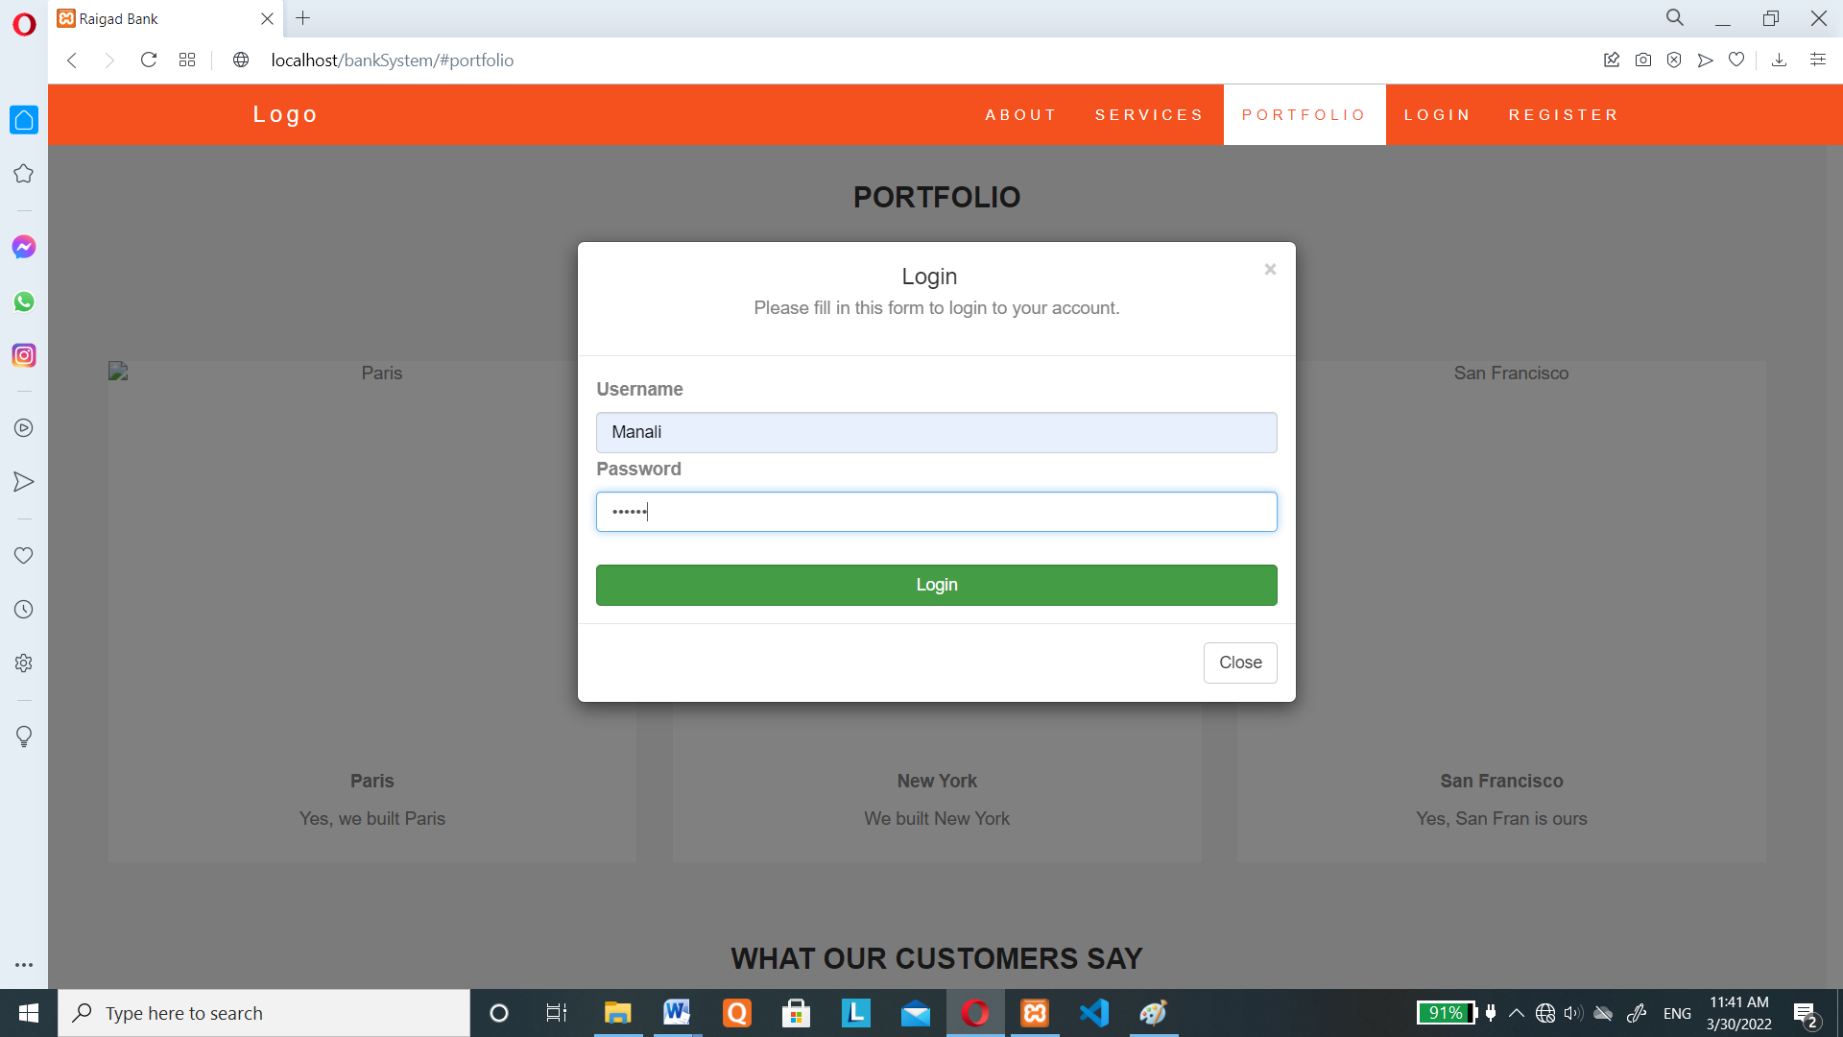

<!DOCTYPE html>

<html>

<head>

<meta name="viewport" content="width=device-width, initial-scale=1">

<style>

body {font-family: Arial, Helvetica, sans-serif;}

/* Full-width input fields */

input[type=text], input[type=password] {

  width: 100%;

  padding: 12px 20px;

  margin: 8px 0;

  display: inline-block;

  border: 1px solid #ccc;

  box-sizing: border-box;

}

/* Set a style for all buttons */

button {

  background-color: #04AA6D;

  color: white;

  padding: 14px 20px;

  margin: 8px 0;

  border: none;

  cursor: pointer;

  width: 100%;

}

button:hover {

  opacity: 0.8;

}

/* Extra styles for the cancel button */

.cancelbtn {

  width: auto;

  padding: 10px 18px;

  background-color: #f44336;

}

/* Center the image and position the close button */

.imgcontainer {

  text-align: center;

  margin: 24px 0 12px 0;

  position: relative;

}

img.avatar {

  width: 40%;

  border-radius: 50%;

}

.container {

  padding: 16px;

}

span.psw {

  float: right;

  padding-top: 16px;

}

/* The Modal (background) */

.modal {

  display: none; /* Hidden by default */

  position: fixed; /* Stay in place */

  z-index: 1; /* Sit on top */

  left: 0;

  top: 0;

  width: 100%; /* Full width */

  height: 100%; /* Full height */

  overflow: auto; /* Enable scroll if needed */

  background-color: rgb(0,0,0); /* Fallback color */

  background-color: rgba(0,0,0,0.4); /* Black w/ opacity */

  padding-top: 60px;

}

/* Modal Content/Box */

.modal-content {

  background-color: #fefefe;

  margin: 5% auto 15% auto; /* 5% from the top, 15% from the bottom and centered */

  border: 1px solid #888;

  width: 80%; /* Could be more or less, depending on screen size */

}

/* The Close Button (x) */

.close {

  position: absolute;

  right: 25px;

  top: 0;

  color: #000;

  font-size: 35px;

  font-weight: bold;

}

.close:hover,

.close:focus {

  color: red;

  cursor: pointer;

}

/* Add Zoom Animation */

.animate {

  -webkit-animation: animatezoom 0.6s;

  animation: animatezoom 0.6s

}

@-webkit-keyframes animatezoom {

  from {-webkit-transform: scale(0)}

  to {-webkit-transform: scale(1)}

}

@keyframes animatezoom {

  from {transform: scale(0)}

  to {transform: scale(1)}

}

/* Change styles for span and cancel button on extra small screens */

@media screen and (max-width: 300px) {

  span.psw {

     display: block;

     float: none;

  }

  .cancelbtn {

     width: 100%;

  }

}

</style>

</head>

<body>

<h2>Modal Login Form</h2>

<button onclick="document.getElementById('id01').style.display='block'" style="width:auto;">Login</button>

<div id="id01" class="modal">

  <form class="modal-content animate" action="/action_page.php" method="post">

    <div class="container">

      <center>

        <h1>Login</h1>

        <p>Please fill in this form to login to your account.</p>

      </center>

      <br>

      <label for="uname"><b>Username</b></label>

      <input type="text" placeholder="Enter Username" name="uname" required>

      <label for="psw"><b>Password</b></label>

      <input type="password" placeholder="Enter Password" name="psw" required>

      <button type="submit">Login</button>

      <label>

        <input type="checkbox" checked="checked" name="remember"> Remember me

      </label>

    </div>

    <div class="container" style="background-color:#f1f1f1">

      <button type="button" onclick="document.getElementById('id01').style.display='none'" class="cancelbtn">Cancel</button>

      <span class="psw"><a href="#">Forgot Password?</a></span>

    </div>

  </form>

</div>

<script>

// Get the modal

var modal = document.getElementById('id01');

// When the user clicks anywhere outside of the modal, close it

window.onclick = function(event) {

    if (event.target == modal) {

        modal.style.display = "none";

    }

}

</script>

</body>

</html>

**Registration Form:**

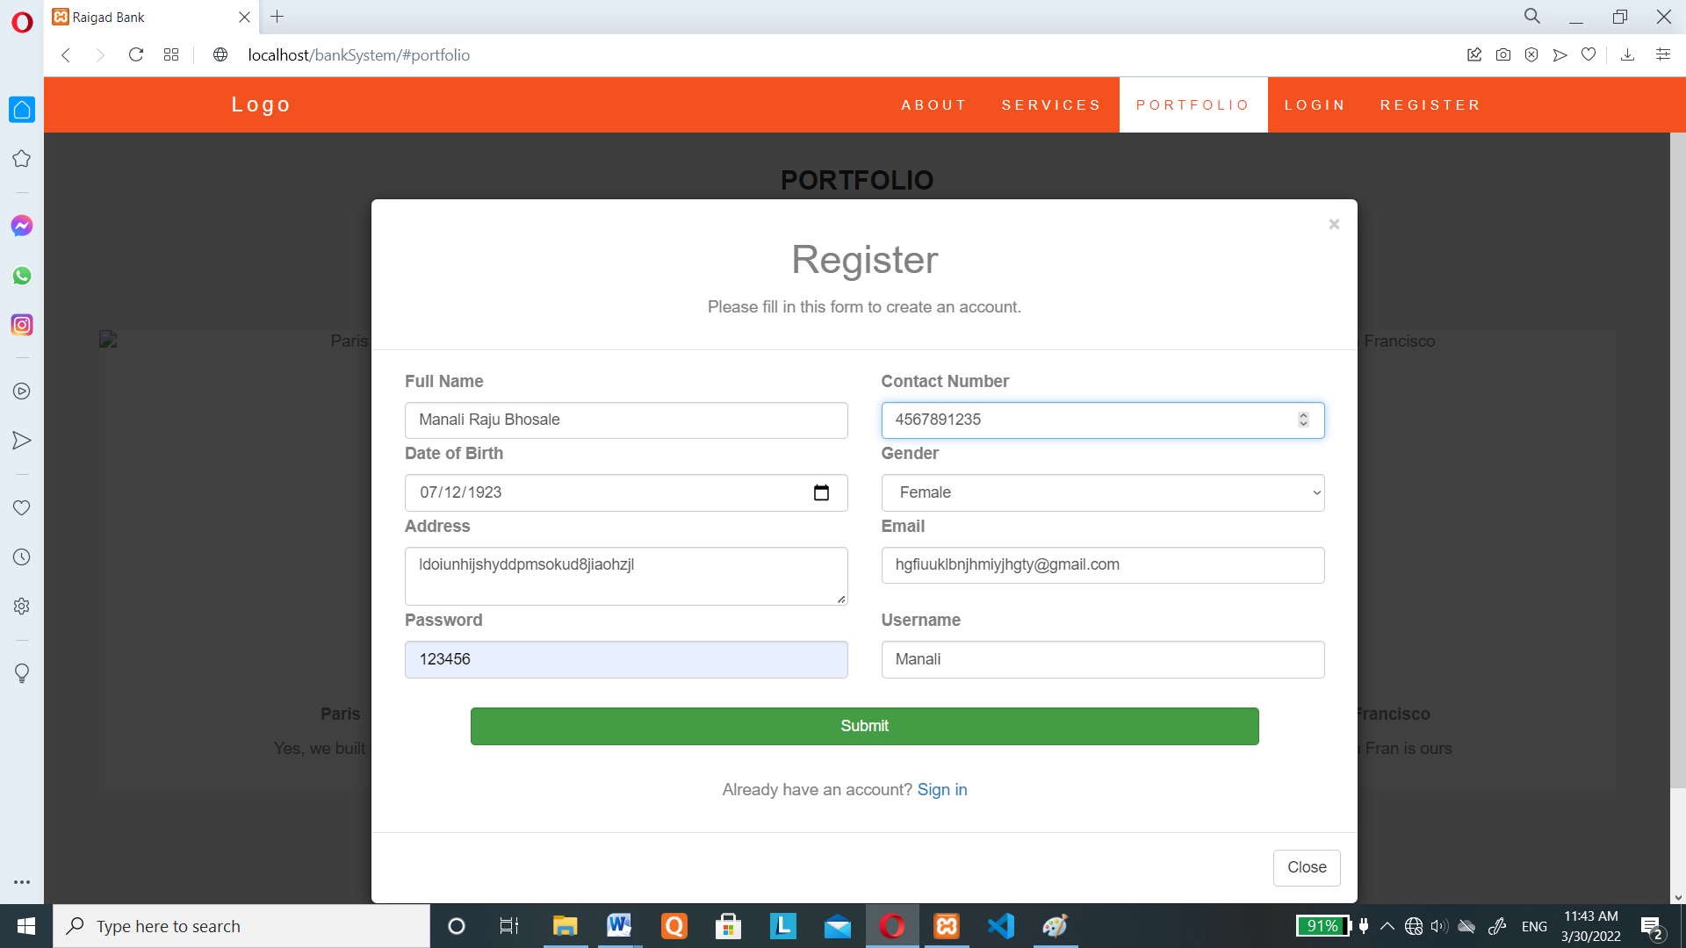

<form action="action.php" method="post">

  <input type="hidden" name="register_action" value="yes">

  <div class="row">

    <div class="col-sm-12">

      <div class="col-sm-6">

        <label for="fullname"><b>Full Name</b></label>

        <input type="text" class="form-control" placeholder="Enter Full Name" name="fullname" id="fullname" required>

      </div>

      <div class="col-sm-6">

        <label for="contact"><b>Contact Number</b></label>

        <input type="number" class="form-control" placeholder="Enter Contact Number" name="contact" id="contact" required>

      </div>

    </div>

  </div>

  <div class="row">

    <div class="col-sm-12">

      <div class="col-sm-6">

        <label for="dob"><b>Date of Birth</b></label>

        <input type="date" class="form-control" placeholder="Enter Date of Birth" name="dob" id="dob" required>

      </div>

      <div class="col-sm-6">

        <label for="gender"><b>Gender</b></label>

        <select name="gender" class="form-control" required>

          <option value="">Select Gender</option>

          <option value="male">Male</option>

          <option value="female">Female</option>

        </select>

      </div>

    </div>

  </div>

  <div class="row">

    <div class="col-sm-12">

      <div class="col-sm-6">

        <label for="address"><b>Address</b></label>

        <textarea type="address" class="form-control" placeholder="Enter Address" name="address" id="address" required></textarea>

      </div>

      <div class="col-sm-6">

        <label for="email"><b>Email</b></label>

        <input type="text" class="form-control" placeholder="Enter Email" name="email" id="email" required>

      </div>

    </div>

  </div>

  <div class="row">

    <div class="col-sm-12">

      <div class="col-sm-6">

        <label for="psw"><b>Password</b></label>

        <input type="text" class="form-control" placeholder="Enter Password" name="psw" id="psw" required>

      </div>

      <div class="col-sm-6">

        <label for="psw-repeat"><b>Username</b></label>

        <input type="text" class="form-control" placeholder="Enter Username" name="username" id="username" required>

      </div>

    </div>

  </div>

  <br>

  <div class="row">

    <div class="col-sm-1"></div>

    <div class="col-sm-10">

      <center><button type="submit" class="btn btn-success form-control">Submit</button></center>

    </div>

    <div class="col-sm-1"></div>

  </div>

  <br>

  <div class="row">

    <div class="col-sm-12">

      <div class="col-sm-4"></div>

      <div class="col-sm-6"><p>Already have an account? <a href="index.php">Sign in</a></p></div>

    </div>

  </div>

</form>

**Dashboard:**

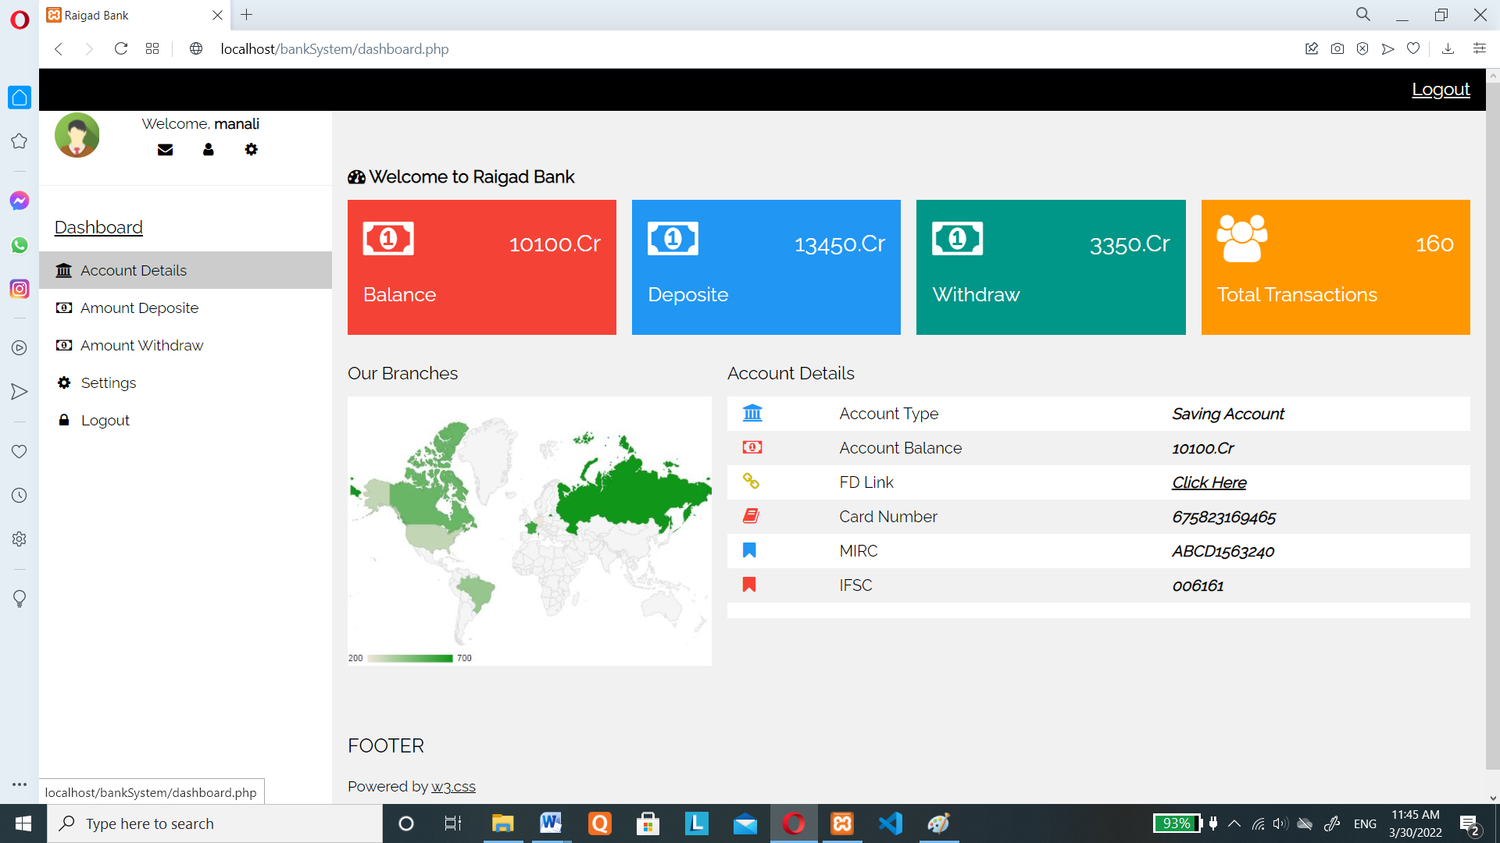

-<?php include('header.php'); ?>

<!-- !PAGE CONTENT! -->

<div class="w3-main" style="margin-left:300px;margin-top:43px;">

  <!-- Header -->

  <header class="w3-container" style="padding-top:22px">

    <h5><b><i class="fa fa-dashboard"></i> Welcome to Raigad Bank</b></h5>

  </header>

  <div class="w3-row-padding w3-margin-bottom">

    <div class="w3-quarter">

      <div class="w3-container w3-red w3-padding-16">

        <div class="w3-left"><i class="fa fa-money w3-xxxlarge"></i></div>

        <div class="w3-right">

          <h3><?php echo $balance_amt; ?>.Cr</h3>

        </div>

        <div class="w3-clear"></div>

        <h4>Balance</h4>

      </div>

    </div>

    <div class="w3-quarter">

      <div class="w3-container w3-blue w3-padding-16">

        <div class="w3-left"><i class="fa fa-money w3-xxxlarge"></i></div>

        <div class="w3-right">

          <h3><?php echo $deposite_amt; ?>.Cr</h3>

        </div>

        <div class="w3-clear"></div>

        <h4>Deposite</h4>

      </div>

    </div>

    <div class="w3-quarter">

      <div class="w3-container w3-teal w3-padding-16">

        <div class="w3-left"><i class="fa fa-money w3-xxxlarge"></i></div>

        <div class="w3-right">

          <h3><?php echo $withdraw_amt; ?>.Cr</h3>

        </div>

        <div class="w3-clear"></div>

        <h4>Withdraw</h4>

      </div>

    </div>

    <div class="w3-quarter">

      <div class="w3-container w3-orange w3-text-white w3-padding-16">

        <div class="w3-left"><i class="fa fa-users w3-xxxlarge"></i></div>

        <div class="w3-right">

          <h3><?php echo $transaction_cnt; ?>0</h3>

        </div>

        <div class="w3-clear"></div>

        <h4>Total Transactions</h4>

      </div>

    </div>

  </div>

  <div class="w3-panel">

    <div class="w3-row-padding" style="margin:0 -16px">

      <div class="w3-third">

        <h5>Our Branches</h5>

        <img src="https://www.w3schools.com/w3images/region.jpg" style="width:100%" alt="Google Regional Map">

      </div>

      <div class="w3-twothird">

        <h5>Account Details</h5>

        <table class="w3-table w3-striped w3-white">

          <tr>

            <td><i class="fa fa-bank w3-text-blue w3-large"></i></td>

            <td>Account Type</td>

            <td><i><b>Saving Account</b></i></td>

          </tr>

          <tr>

            <td><i class="fa fa-money w3-text-red w3-large"></i></td>

            <td>Account Balance</td>

            <td><i><b><?php echo $balance_amt; ?>.Cr</b></i></td>

          </tr>

          <tr>

            <td><i class="fa fa-link w3-text-yellow w3-large"></i></td>

            <td>FD Link</td>

            <td><i><b><a href="#">Click Here</a></b></i></td>

          </tr>

          <tr>

            <td><i class="fa fa-book w3-text-red w3-large"></i></td>

            <td>Card Number</td>

            <td><i><b>675823169465</b></i></td>

          </tr>

          <tr>

            <td><i class="fa fa-bookmark w3-text-blue w3-large"></i></td>

            <td>MIRC</td>

            <td><i><b>ABCD1563240</b></i></td>

          </tr>

          <tr>

            <td><i class="fa fa-bookmark w3-text-red w3-large"></i></td>

            <td>IFSC</td>

            <td><i><b>006161</b></i></td>

          </tr>

          <tr>

            <td></td>

            <td></td>

            <td></td>

          </tr>

        </table>

      </div>

    </div>

  </div>

  <hr>

<?php include('footer.php'); ?>

**Amount Deposit:**

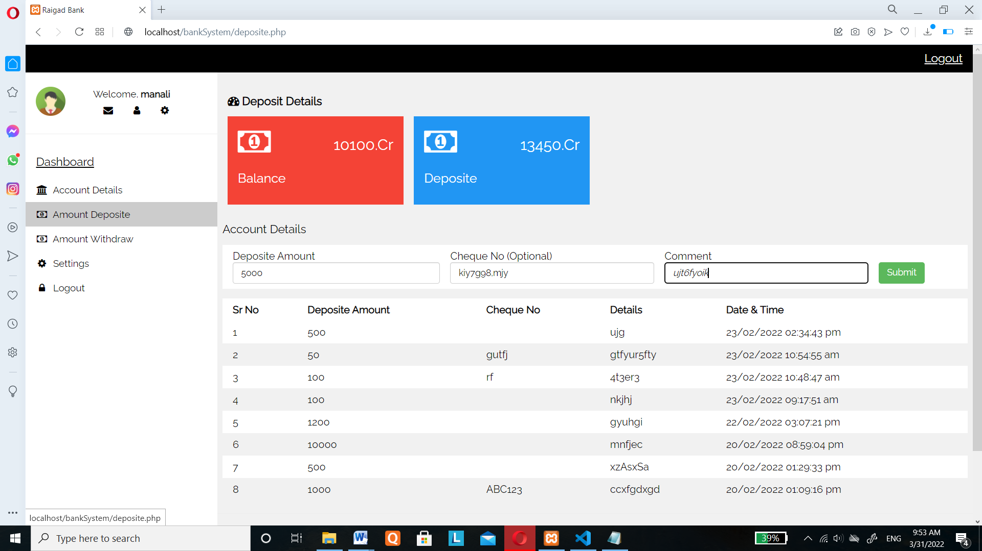

<style>

    .btn-success {

        color: #fff;

        background-color: #5cb85c;

        border-color: #4cae4c;

    }

    .btn {

        display: inline-block;

        margin-bottom: 0;

        font-weight: 400;

        text-align: center;

        white-space: nowrap;

        vertical-align: middle;

        touch-action: manipulation;

        cursor: pointer;

        background-image: none;

        border: 1px solid transparent;

        padding: 6px 12px;

        font-size: 14px;

        line-height: 1.42857143;

        border-radius: 4px;

        user-select: none;

    }

    .form-control {

        display: block;

        width: 100%;

        height: 34px;

        padding: 6px 12px;

        font-size: 14px;

        line-height: 1.42857143;

        border: 1px solid #ccc;

        border-radius: 4px;

        box-shadow: inset 0 1px 1px rgb(0 0 0 / 8%);

        transition: border-color ease-in-out .15s,box-shadow ease-in-out .15s,-webkit-box-shadow ease-in-out .15s;

    }

</style>

<?php include('header.php'); ?>

<!-- !PAGE CONTENT! -->

<div class="w3-main" style="margin-left:300px;margin-top:43px;">

  <!-- Header -->

  <header class="w3-container" style="padding-top:22px">

    <h5><b><i class="fa fa-dashboard"></i> Deposit Details</b></h5>

  </header>

  <div class="w3-row-padding w3-margin-bottom">

    <div class="w3-quarter">

      <div class="w3-container w3-red w3-padding-16">

        <div class="w3-left"><i class="fa fa-money w3-xxxlarge"></i></div>

        <div class="w3-right">

          <h3><?php echo $balance_amt; ?>.Cr</h3>

        </div>

        <div class="w3-clear"></div>

        <h4>Balance</h4>

      </div>

    </div>

    <div class="w3-quarter">

      <div class="w3-container w3-blue w3-padding-16">

        <div class="w3-left"><i class="fa fa-money w3-xxxlarge"></i></div>

        <div class="w3-right">

          <h3><?php echo $deposite_amt; ?>.Cr</h3>

        </div>

        <div class="w3-clear"></div>

        <h4>Deposite</h4>

      </div>

    </div>

  </div>

  <div class="w3-panel">

    <div class="w3-row-padding" style="margin:0 -16px">

      <div class="w3">

        <h5>Account Details</h5>

        <div class="w3-white">

            <form method="post" name="deposit_form" action="action.php">

                <input type="hidden" name="deposite_action" value="yes">

                <table class="w3-table w3-striped w3-white">

                  <tr>

                    <td>Deposite Amount<br><input type="number" name="deposite_amount" class="form-control" required></td>

                    <td>Cheque No (Optional)<br><input type="text" id="cheque_no" name="cheque_no" class="form-control"></td>

                    <td>Comment<br><var><input type="text" name="comment" class="form-control" required></var></td>

                    <td><br><input type="submit" value="Submit" name="submit" class="btn btn-success"></td>

                  </tr>

                 </table>

            </form>

        </div>

        <table class="w3-table w3-striped w3-white">

            <thead>

                <tr>

                    <th>Sr No</th>

                    <th>Deposite Amount</th>

                    <th>Cheque No</th>

                    <th>Details</th>

                    <th>Date & Time</th>

                </tr>

            </thead>

                <?php $i=1;

                while ($row1 = mysqli_fetch_array($result1)) {

                    if($row1['deposite'] > 0) {

                ?>

                  <tr>

                    <td><?php echo $i ?></td>

                    <td><?php echo $row1['deposite']; ?></td>

                    <td><?php echo $row1['cheque_no']; ?></td>

                    <td><?php echo $row1['comment']; ?></td>

                    <td><?php echo date('d/m/Y h:i:s a', strtotime($row1['date'])); ?></td>

                  </tr>

                <?php $i++; } ?>

                 <?php } ?>

        </table>

      </div>

    </div>

  </div>

  <hr>

</div>

<?php include('footer.php'); ?>

**Amount Withdraw:**

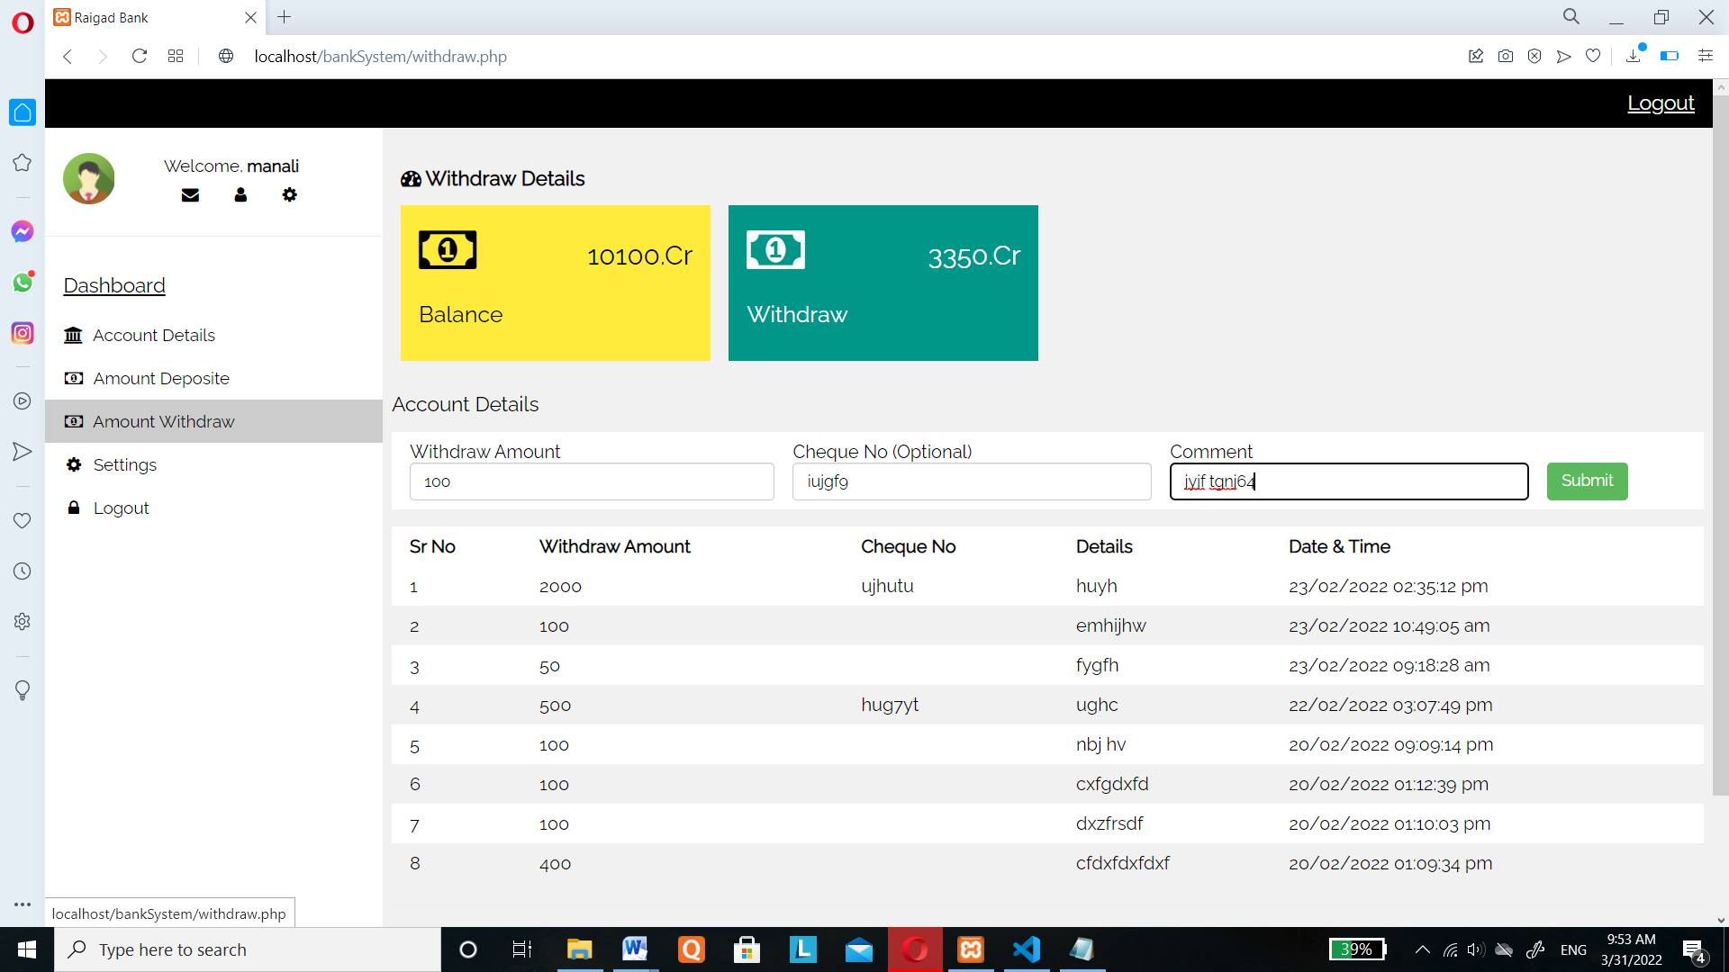

<style>

    .btn-success {

        color: #fff;

        background-color: #5cb85c;

        border-color: #4cae4c;

    }

    .btn {

        display: inline-block;

        margin-bottom: 0;

        font-weight: 400;

        text-align: center;

        white-space: nowrap;

        vertical-align: middle;

        touch-action: manipulation;

        cursor: pointer;

        background-image: none;

        border: 1px solid transparent;

        padding: 6px 12px;

        font-size: 14px;

        line-height: 1.42857143;

        border-radius: 4px;

        user-select: none;

    }

    .form-control {

        display: block;

        width: 100%;

        height: 34px;

        padding: 6px 12px;

        font-size: 14px;

        line-height: 1.42857143;

        border: 1px solid #ccc;

        border-radius: 4px;

        box-shadow: inset 0 1px 1px rgb(0 0 0 / 8%);

        transition: border-color ease-in-out .15s,box-shadow ease-in-out .15s,-webkit-box-shadow ease-in-out .15s;

    }

</style>

<?php include('header.php'); ?>

<!-- !PAGE CONTENT! -->

<div class="w3-main" style="margin-left:300px;margin-top:43px;">

  <!-- Header -->

  <header class="w3-container" style="padding-top:22px">

    <h5><b><i class="fa fa-dashboard"></i> Withdraw Details</b></h5>

  </header>

  <div class="w3-row-padding w3-margin-bottom">

    <div class="w3-quarter">

      <div class="w3-container w3-yellow w3-padding-16">

        <div class="w3-left"><i class="fa fa-money w3-xxxlarge"></i></div>

        <div class="w3-right">

          <h3><?php echo $balance_amt; ?>.Cr</h3>

        </div>

        <div class="w3-clear"></div>

        <h4>Balance</h4>

      </div>

    </div>

    <div class="w3-quarter">

      <div class="w3-container w3-teal w3-padding-16">

        <div class="w3-left"><i class="fa fa-money w3-xxxlarge"></i></div>

        <div class="w3-right">

          <h3><?php echo $withdraw_amt; ?>.Cr</h3>

        </div>

        <div class="w3-clear"></div>

        <h4>Withdraw</h4>

      </div>

    </div>

  </div>

  <div class="w3-panel">

    <div class="w3-row-padding" style="margin:0 -16px">

      <div class="w3">

        <h5>Account Details</h5>

        <div class="w3-white">

            <form method="post" name="withdraw_form" action="action.php">

                <input type="hidden" name="withdraw_action" value="yes">

                <table class="w3-table w3-striped w3-white">

                  <tr>

                    <td>Withdraw Amount<br><input type="number" name="withdraw_amount" class="form-control" required></td>

                    <td>Cheque No (Optional)<br><input type="text" id="cheque_no" name="cheque_no" class="form-control"></td>

                    <td>Comment<br><input type="text" name="comment" class="form-control" required></td>

                    <td><br><input type="submit" value="Submit" name="submit" class="btn btn-success"></td>

                  </tr>

                 </table>

            </form>

        </div>

        <table class="w3-table w3-striped w3-white">

            <thead>

                <tr>

                    <th>Sr No</th>

                    <th>Withdraw Amount</th>

                    <th>Cheque No</th>

                    <th>Details</th>

                    <th>Date & Time</th>

                </tr>

            </thead>

                <?php $i=1;

                while ($row1 = mysqli_fetch_array($result1)) {

                    if($row1['withdraw'] > 0) {  ?>

                  <tr>

                    <td><?php echo $i ?></td>

                    <td><?php echo $row1['withdraw']; ?></td>

                    <td><?php echo $row1['cheque_no']; ?></td>

                    <td><?php echo $row1['comment']; ?></td>

                    <td><?php echo date('d/m/Y h:i:s a', strtotime($row1['date'])); ?></td>

                  </tr>

                <?php $i++; } ?>

                <?php } ?>

        </table>

      </div>

    </div>

  </div>

  <hr>

</div>

<?php include('footer.php'); ?>

**Logout :**

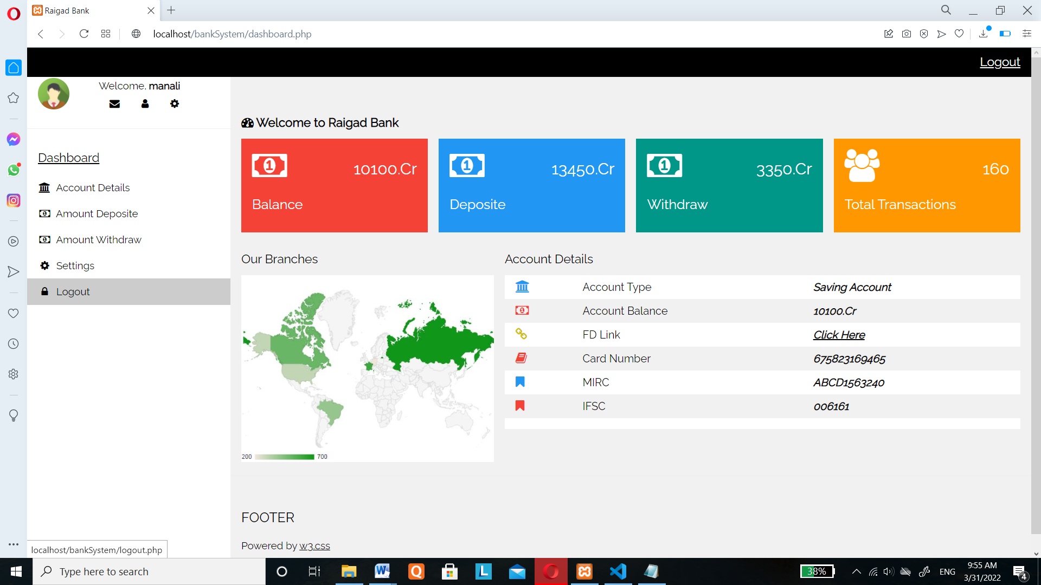

<?php

include('db.php');

session_destroy();

header('Location: index.php');

?>

**Chapter 9:**

**REFERANCE**

**Book Reference:**

* Online Websites
* Book Name: A Beginner’s Guide

Auther: Vikram Vaswani

* Some YouTube Channel
* Project Teacher Help